Project Background:
After being introduced to MATLAB at university as part of my first-year course, I became curious about the software and was keen to develop my knowledge and skills further. As a result, I continued learning beyond the basic MATLAB Onramp course that I completed as part of my university studies, progressing to the Simulink, Simscape, and Simscape Battery Onramp courses.
I then wanted to put my newly developed skills into practice by completing a project using the software. I decided to design and create a battery using the MATLAB Battery Builder app, with the aim of replicating an existing electric bicycle battery. I then planned to extend the project by incorporating the battery model into simulations of real-world electric bicycle applications.

Project Aim:
To simulate and model the behaviour and performance of an electric bicycle battery under different use and background conditions using MATLAB, Simulink and Simscape.

Battery Design:

Battery Specification:
I decided to model the following battery because I was able to find a lot of technical data on it: https://greencell.global/en/e-bike-batteries/5674-gc-silverfish-battery-for-electric-bike-ebike-with-charger-36v-104ah-374wh-xlr-3-pin-ia-for-zuendapp-polish-production.html - specification
Battery Name: Green Cell Silverfish | Dimensions: 350 x 84 x 84 mm
Voltage: 36V | Total Weight: 2.78kg
Capacity: 10.4 Ah | Motor Rating: 250W, max 500W

Cell Specification:
This image can be found on the website linked above. Although the website does not explicitly state that the image shows the specific battery model listed, I was unable to find any more reliable information. Therefore, this image represents the best estimate of the battery's appearance based on the information available. | 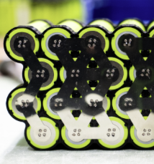  Figure 1
I found visually identical cells listed on the same company’s website. Each cell adheres to the 18650-battery standard and has the specification below:
Cell Capacity: 2.6 Ah | Charging voltage: 4.2V
Cell Voltage: 3.6 V | Cell Energy: 9.36Wh  ( $E=Q*V=2.6Ah*3.6V=9.36 Wh$
Cell Weight 46g  (website states that pack of 20 weighs 920g) | Standard Currents:  - Discharge: 1C-rate / 2.6A  - Charge: 0.5C-rate / 1.30A
Internal Resistance: 27.5m$Ω$  (Website states <28m$Ω$ so for this project I will consider 27.5m$Ω$ ) | Working Temperatures:  - Discharging: -20-60°C  - Charging: 0-50°C

The listing title states 2900mAh capacity and 3.7 V output voltage, but the specification section further down the page states 2600mAh and 3.6V. I went with the latter combination because these values made combining cells to make the battery pack to fit the specification perfectly very simple, which convinced me to think that this is the type of cell used in the battery pack.
When these values are used however, the C-rate equivalent current of the cell also changes from the given 2.9 to 2.6 A. As a result, I also altered the discharge and charge currents in the table above to fit the 1C and 0.5C specification.

Cell Dimensions:
While researching the 18650-battery standard I came across this website where dimensions of each standard cell were stated:
Cell Shape: Cylinder | Cell Length: 65mm
Cell Diameter: 18mm

These measurements confirm my theory that this is the type of cell used in the battery pack. In the photo above (Figure 1) the cells are stacked on their long edge, lying horizontally. The cell length which is 65mm is very close to the battery width, which is 65mm, supporting my theory. The remaining space will be used up surrounding electronics, connecting plates, casing and padding which is present to make sure the battery survives impacts which the electric bicycle is likely to encounter.
A similar conclusion can be made when considering the height measurement. The picture shows 4 batteries stacked vertically along their long edges. The diameter of each battery is 18mm and so the stack (assuming that cells are stacked vertically on top of each other instead of the more hexagonal structure in the photo) will measure 72mm high. This is less than the overall 84mm battery measurement.
Before considering the length dimensions, I will calculate the number of cells that will lie along this dimension.

Battery Pack Cell Structure:
The battery specification states that the battery pack should have a capacity of 10.4Ah. To alter battery pack capacity, I need to consider making an assembly of cells connected in parallel. In that case, the total capacity will just be the capacity of all the cells in parallel added together. Therefore, my assembly will need $\frac{Battery Capacity}{Cell Capacity}=\frac{10.4}{2.6}=4$ cells connected in parallel.
To alter the battery’s output voltage, I will be connecting these assemblies in series. Each assembly has the output voltage of one cell so 3.6V and the specification needs a battery output of 36V. Therefore, I just need to connect 10 of these parallel assemblies in series to make my battery pack meet the researched specification.
This combination of cells has a technical name 10S4P.
To check if my result is correct, I can check whether my result is consistent with the length dimension requirement. 10 cells in series will take up $18*10=180$mm which is significantly less than the stated 350mm, so the result is correct. The dimensions and the arrangement of the cells in the battery pack will be important when I model the thermal behaviour of the battery pack later in the project.

Designing Battery in Battery Builder app of MATLAB:

Cell:
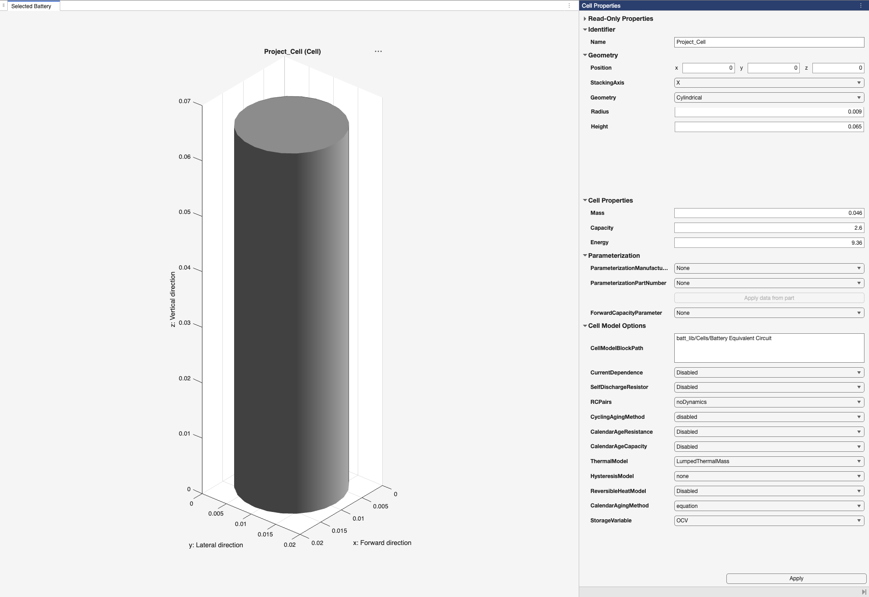
Figure 2
Important Fields:
- Geometry: Cylindrical
- Radius: 0.009m
- Height: 0.065m
- Mass: 0.046kg
- Capacity: 2.6Ah
- 9.36 Wh
- ThermalModel: LumpedThermalMass
Turns on the thermal modelling for each cell. Each cell is considered to
be a single lumped mass so the temperature across the whole cell is modelled as uniform.

Parallel Assembly:
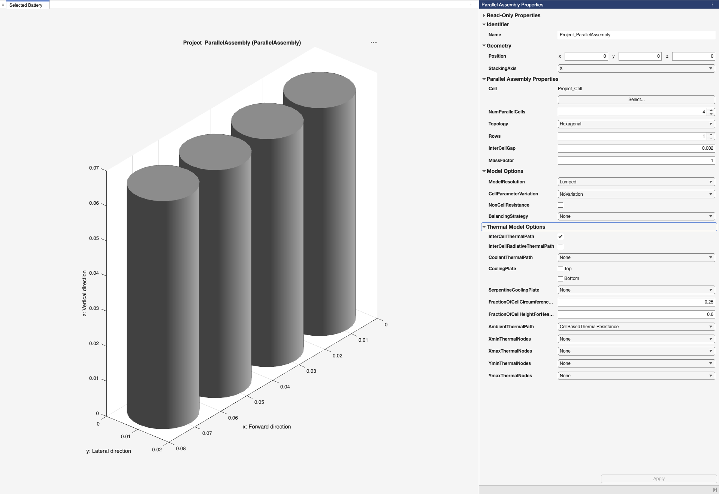
Figure 3
Important Fields:
- NumParallelCells: 4 4 cells will be connected in parallel
- Rows: 1 To define the physical arrangement of the battery cells
- InterCellGap: 0.002m
According to research the industry uses between 1.5 – 3mm for similar cells. This field defines how big of a gap is left between each cell. This is mostly left to allow cells to swell up slightly without disturbing the whole battery structure.
- MassFactor: 1 I will neglect the mass of the plates which connect the cells together
- NonCellResistance: Off I will neglect the effect of the connecting plates’ resistance
- InterCellThermalPath: On Model will simulate heat flows from one cell to another
- AmbientThermalPath: CellBasedThermalResistance the model will simulate heat production on a cell-by-cell basis

Module:
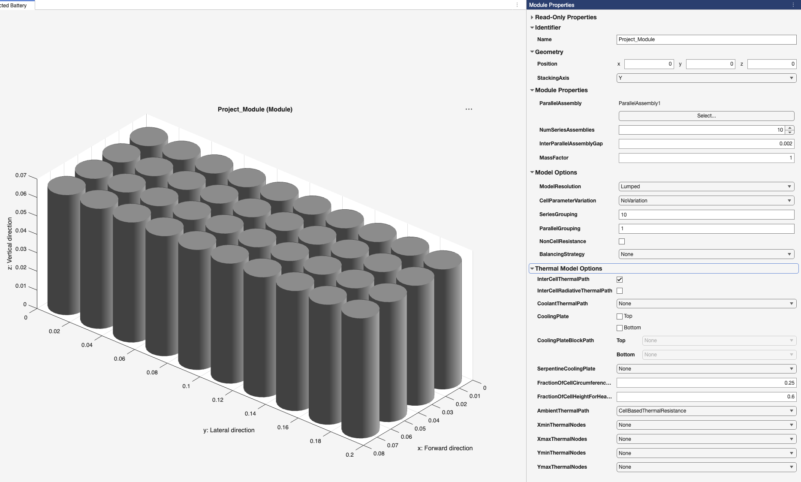
Figure 4
Important Fields:
- NumSeriesAssemblies: 10 10 assemblies will be connected in series
- InterParallelAssemblyGap: 0.002m
- MassFactor: 1
- NonCellResistance: Off
- InterCellThermalPath: On
- AmbientThermalPath: CellBasedThermalResistance

Module Assembly:
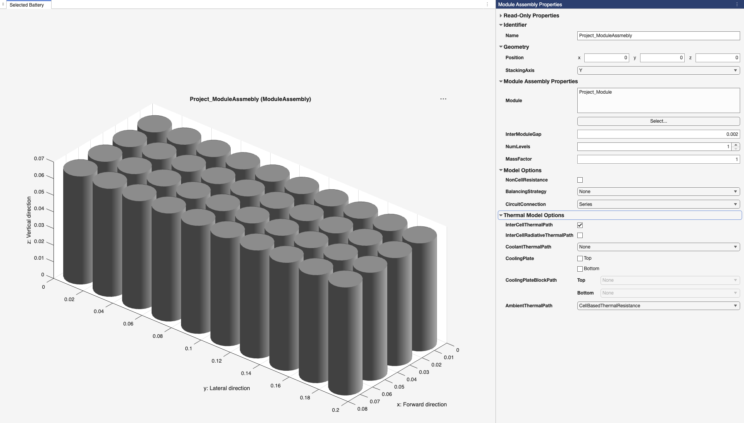
Figure 5
The Module Assembly is just the previously made module with settings copied over.

Battery Pack:
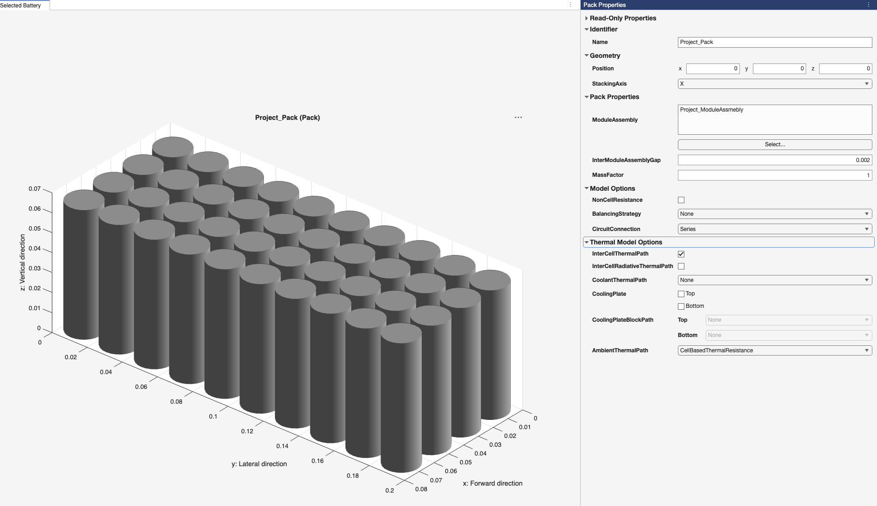
Figure 6
The battery pack is just the previously made module assembly with settings copied over.

Simulations:

Version 1 – Setting up and testing battery parameters:

Setting up battery:
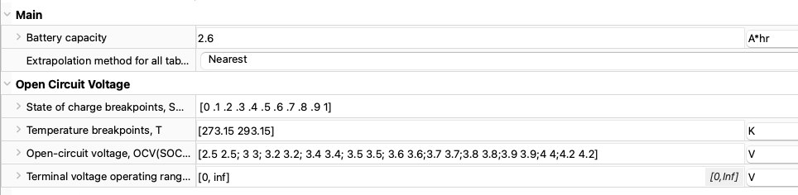
Figure 7
To have accurate properties for the battery pack, I researched how state of charge and temperature impacted the open circuit voltage of a 18650 3.6V battery cell but I struggled to find any good results. I did find a credible result for the open-circuit voltage and state of charge variation for room temperature, however. MATLAB required at least 2 temperature breakpoints, so I put in values of 0 and 20°C. That website did display a graph where temperature was considered, but it was very small and the photo was of a low quality, so I struggled to read it and therefore decided to omit it.
Therefore, for the simulations, I assume that open-circuit voltage does not change with temperature. This will not impact the accuracy of my results until version 4 where I plan to model the battery’s output at different temperature conditions as until then, I will assume that the battery is at room temperature.
Fields changed from default:
- Battery capacity: This variable represents the capacity of a single cell – set to 2.6Ah
- State of charge breakpoints: The battery state of charge for which I will input open-circuit voltages. Set to a row vector of 0,10%,20% … 90%,100%
- Temperature breakpoints: 273.15K and 293.15K so 0 and 20 °C.
- Open-circuit voltage: Data filled in from the referenced study.

Simulink schematic:
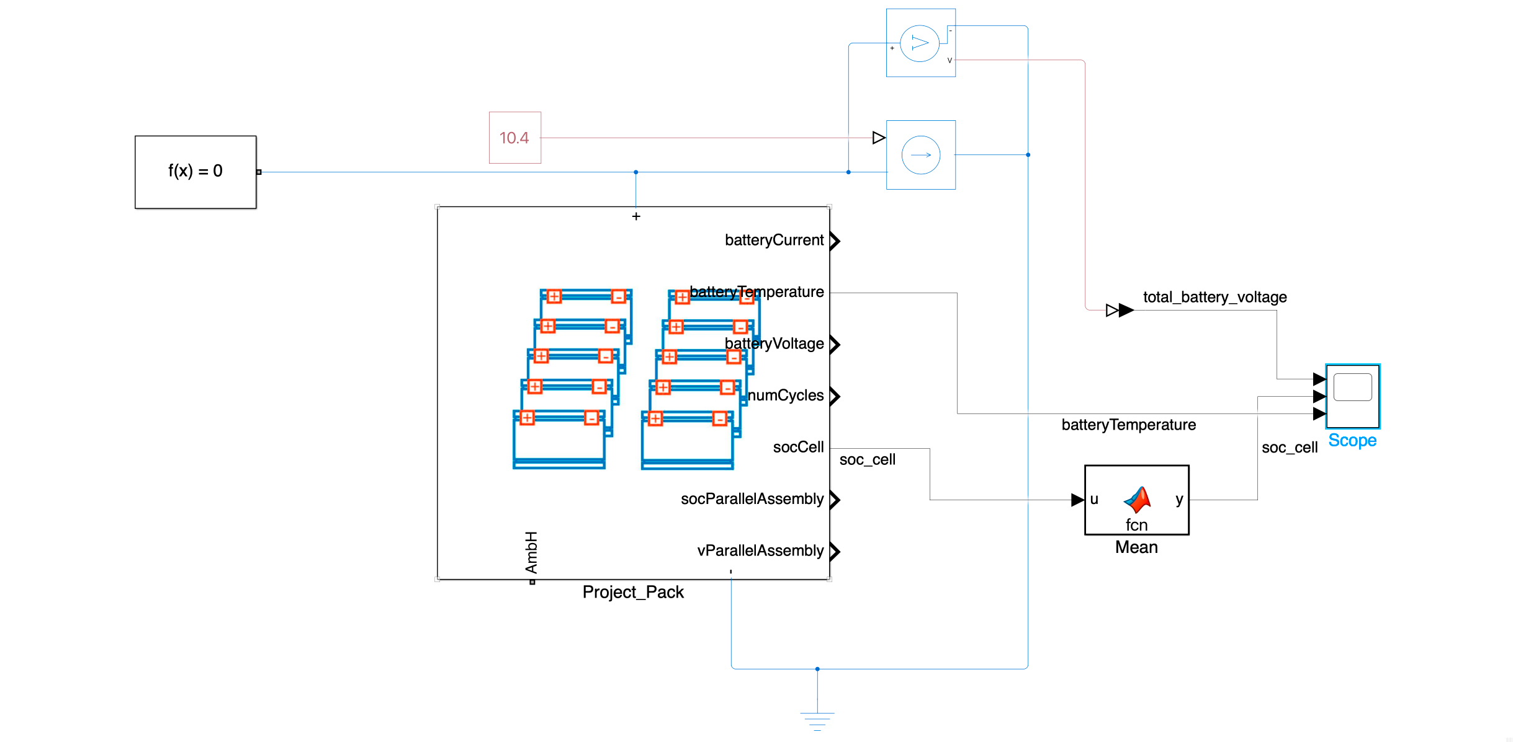
Figure 8
This schematic represents the battery model connected to a constant current source. The current source is set to 10.4A which means that the 10.4Ah battery should fully drain in exactly 1 hour (3600s) if all the parameters have been set out correctly. Because the output current of the battery is constant and the battery is initially fully charged, the state of charge graph should be a linear decrease from 1 at 0s to 0 at 3600s.
I have also connected a voltage meter across the battery to measure its output voltage. For the set up to be correct, the voltage reading when the battery is half full (state of charge= 0.5) should be 36V. The expected shape of the graph should be a decrease in output voltage from more than 36V at 0s to less than 36V at 3600s.
Furthermore, the AmbH port is left unconnected for now. The battery is therefore considered as perfectly insulated as the heat produced by the cells has nowhere to go. We should therefore see the battery temperature increase steadily from around 298.15K (Simulink default for the initial temperature of the battery) throughout the entire simulation.

Output Figure:
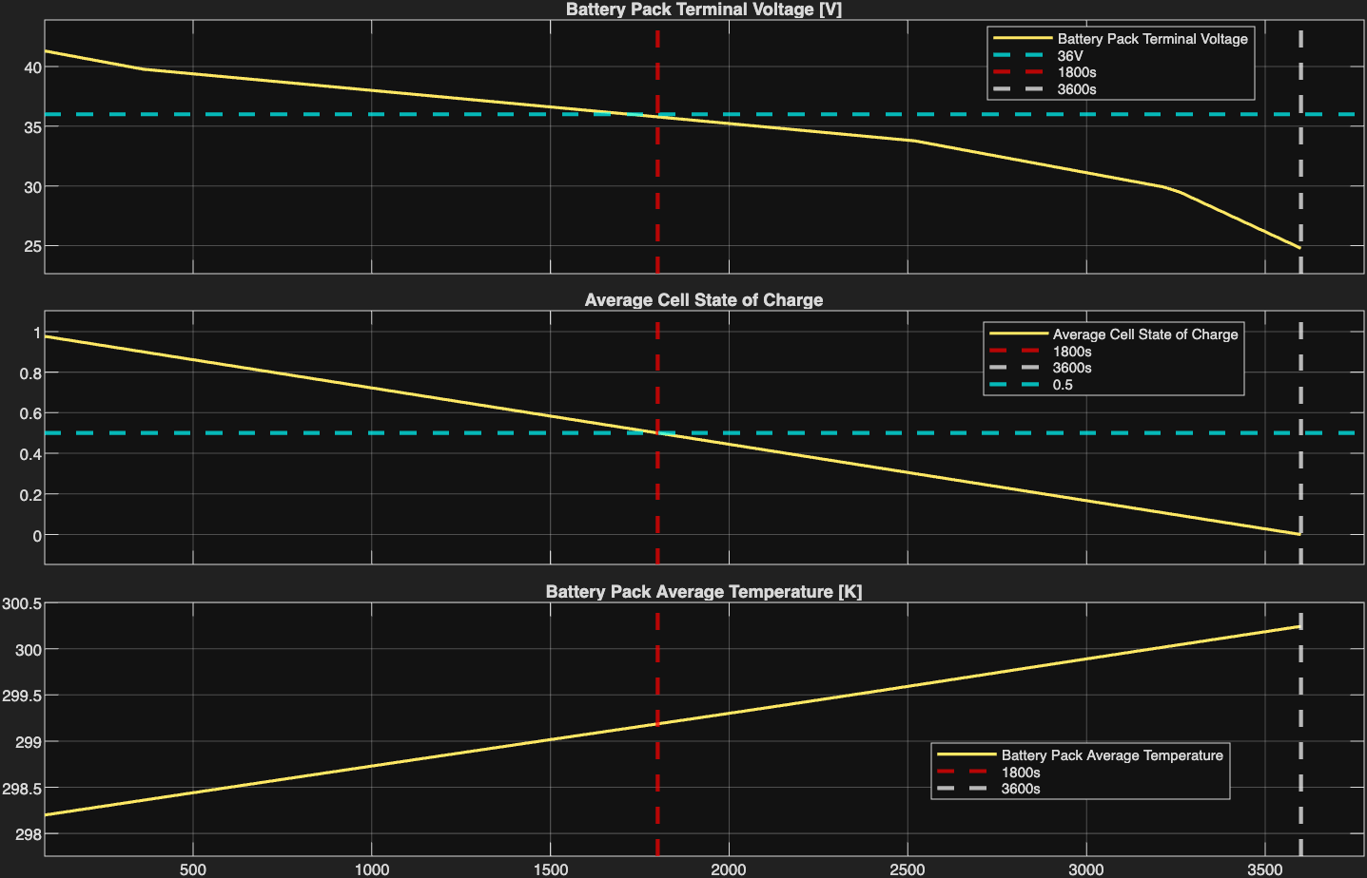
Figure 9
Test Description | Passed? (Yes/No)
Is the state of charge of the battery 0.5 at 1800s | Yes
Is the state of charge of the battery 0.0 at 3600s | Yes
Does the state of charge decrease linearly? | Yes
Is the battery voltage 36V at 1800s? | Yes
Does the voltage graph follow the expected shape? | Yes
Does the temperature graph follow the expected shape? | Yes

All the tests have been passed therefore it is confirmed that the battery has been designed, created and modelled appropriately to fit the specification.

Version 2 – Introducing current controller + soc estimating algorithm:

Simulink Schematic:
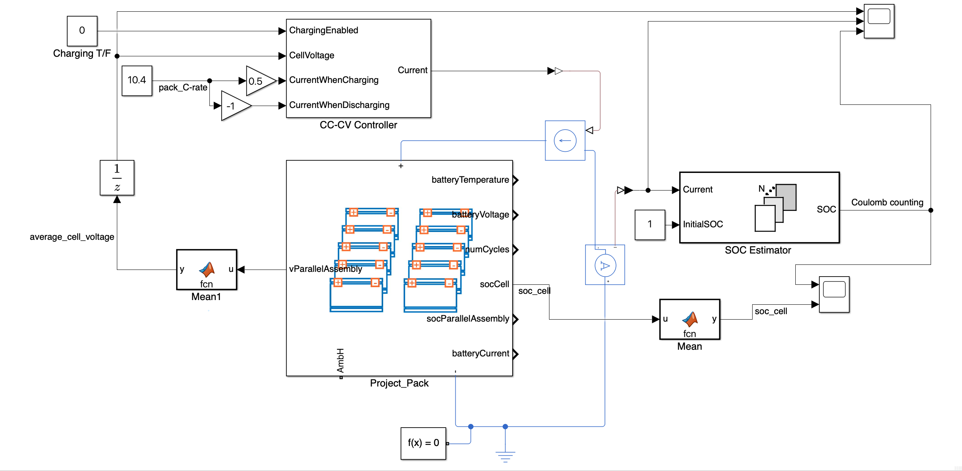
Figure 10
This schematic builds on version 1. The most significant changes are the addition of the CC-CV Controller and the SOC Estimator blocks.
The CC-CV Controller actively chooses what current it wants to use. That information feeds into the controlled current source which then outputs the defined current. If the block is in charge mode, the output current is set to 0.5 C-rate and when in discharge mode, the controller outputs the equivalent of 1 C-rate in the opposite direction, as defined in the cell specification. The on-schematic C-rate current so 10.4A is the sum of the C-rate currents of all the cells in a single parallel assembly (4 cells with 2.6A each).
The controller also monitors the voltage across the cells (voltages of cells in a parallel assembly are identical as cells are connected in parallel). When in charging mode and the cell voltage starts nearing the set limit of 4.2V, meaning that the battery is almost fully charged, the controller will reduce and finally shut off the charging current to prevent the battery from over-charging.
The SOC Estimator block actively estimates the state of charge left in the battery. It uses the Coulomb Counting method to do so. This method integrates the current running through the battery over time to calculate how much charge has been lost or gained compared to the overall battery capacity. This is a better metric than the given data coming out of the socCell because it is not an internal state but an external measurement. In the real world, you cannot measure internal states but have to use an external estimator so the use of one makes the model more realistic.

Output Figures:

State of Charge Comparison:
Discharging: | 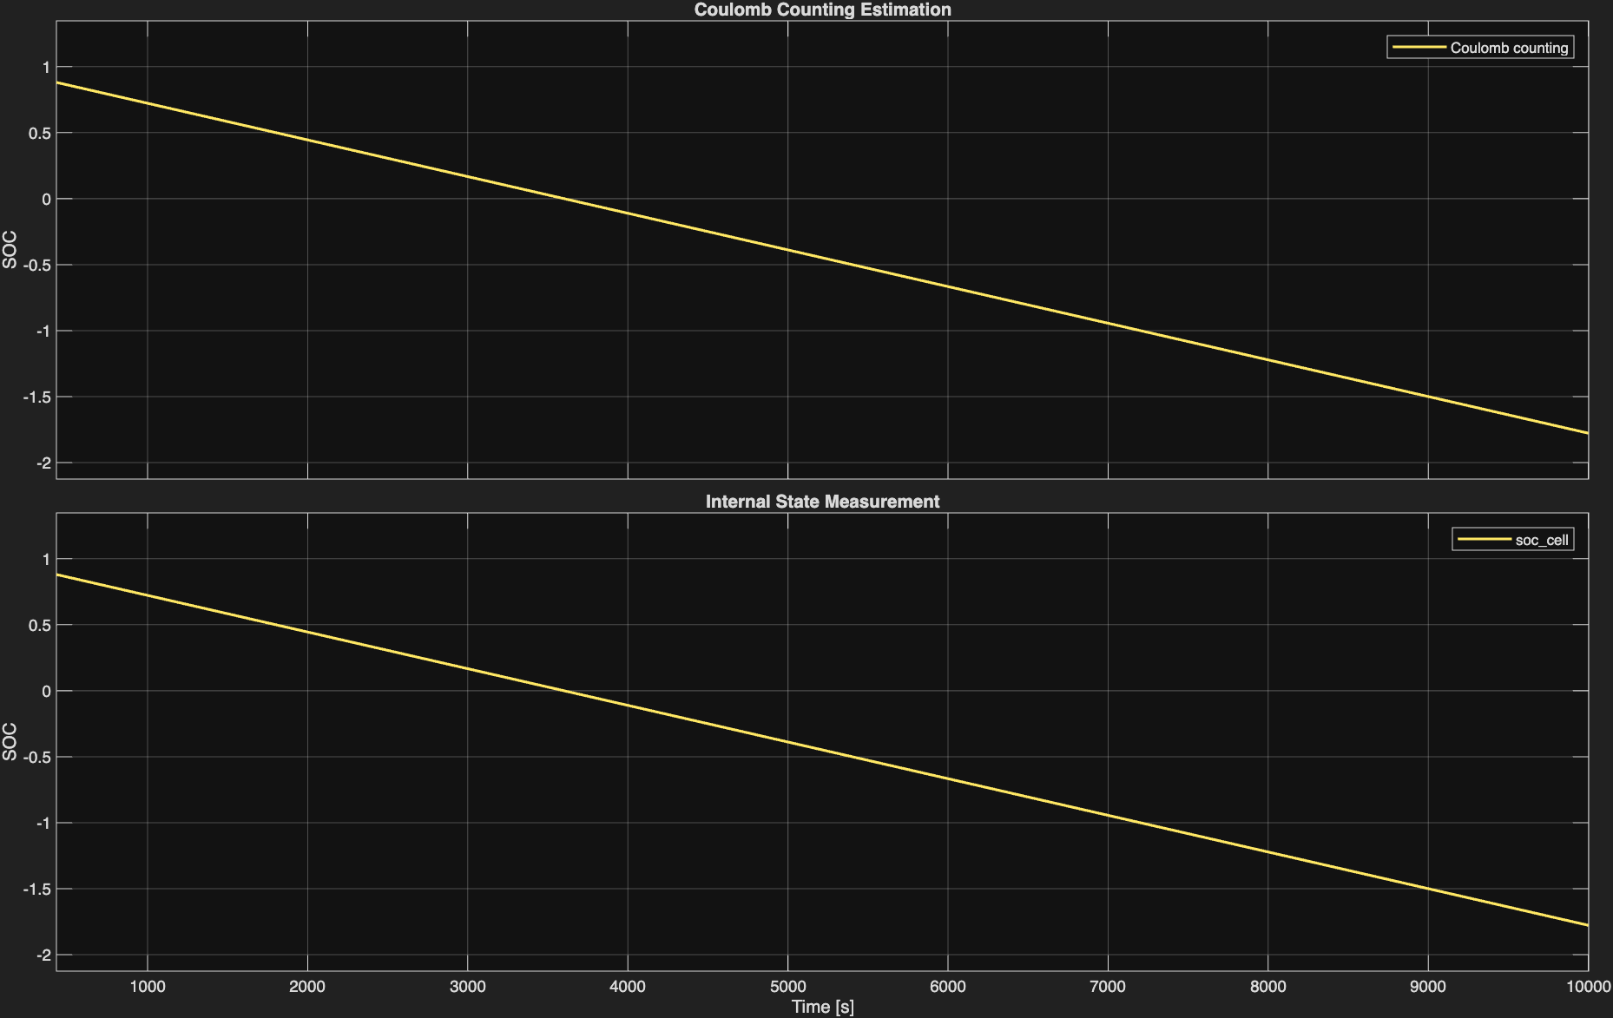  Figure 11
Charging: | 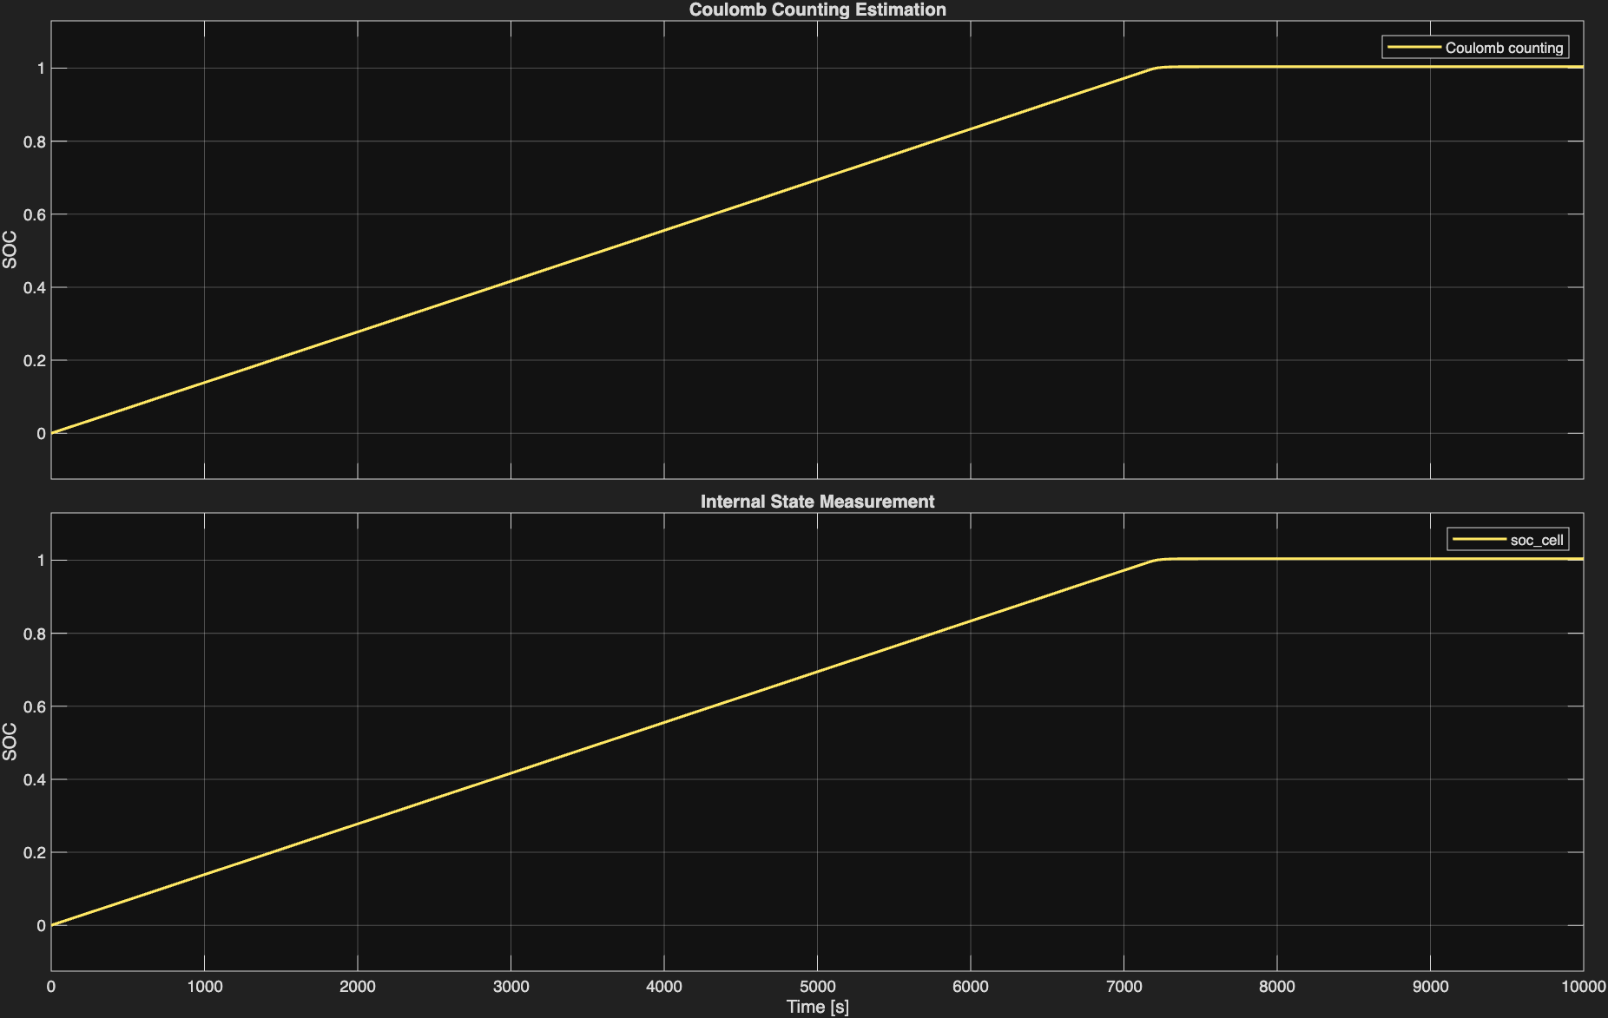  Figure 12

Cell Voltage and Controller Current:
Discharging: | 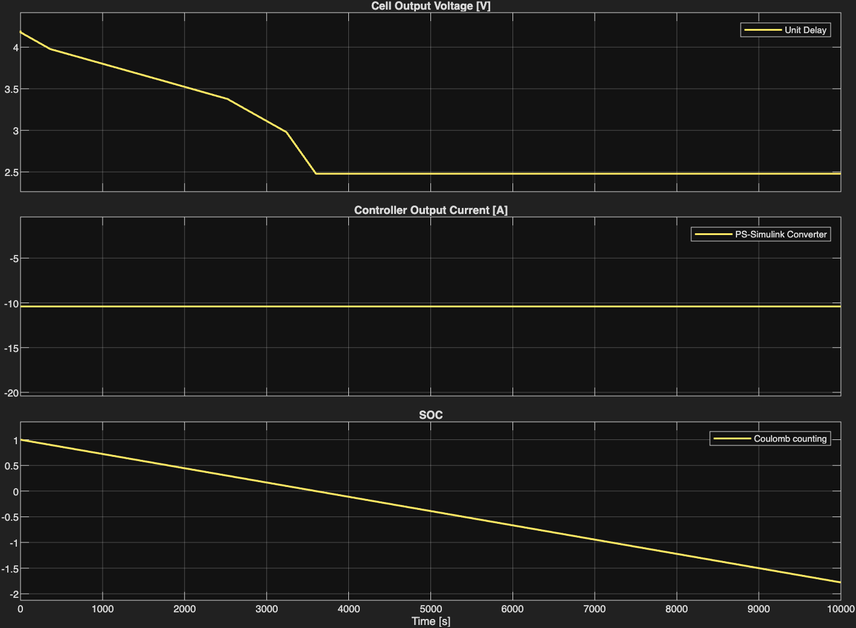 Figure 13
Charging: | 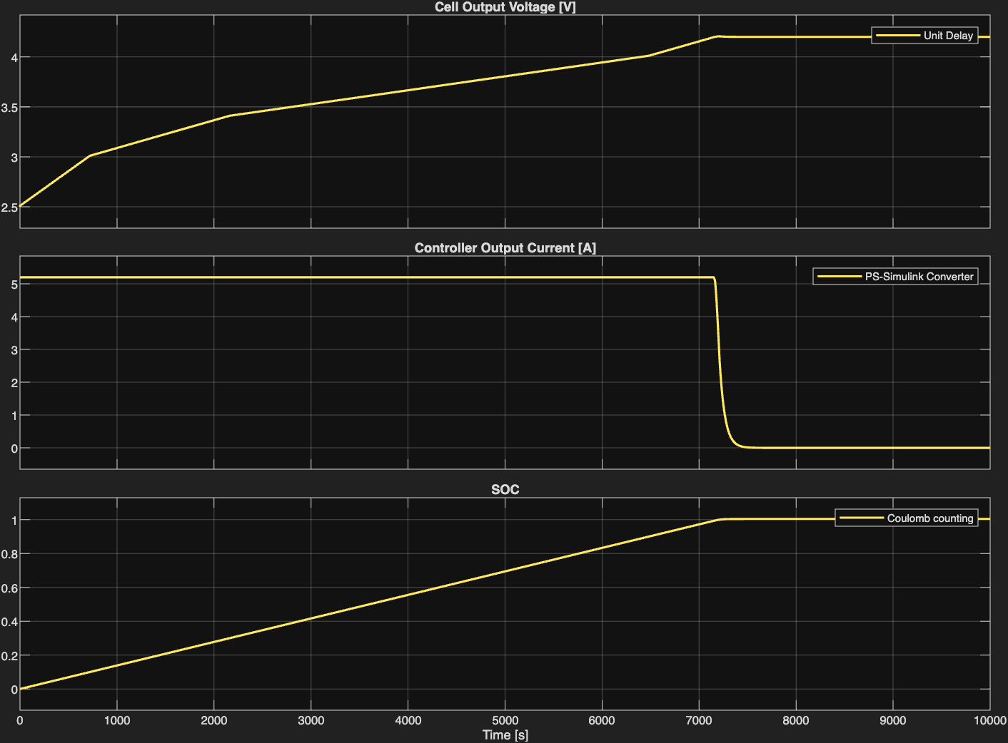  Figure 14
Both sets of graphs show that the CC-CV controller and the SOC Estimator have been implemented correctly.
The SOC Estimator follows the same pattern as the internal state measurement which is exactly as expected. The charging graph also shows the CC-CV current controller working correctly as the SOC never rises above 1, which means that the battery is never overcharged. It can also be seen that the controller outputs a constant current when discharging the battery, regardless of the SOC which is also expected but not accurate in the real world. In that case, the final controller should stop the current to not drain the battery further as that might damage it. That is something to be implemented in further versions.
The cell voltage and controller current graphs also show expected behaviour. In discharging mode, the cell output voltage decreases as the cell is drained until it plateaus at 2.5V when the discharging current remains constant at 1C-rate which is expected as explained above. In charging mode, the battery is charged with the correct 0.5 C-rate current until the battery SOC starts reaching 1 when the controller first decreases and then zeroes the charging current.

Version 3 – Prevention of battery over draining + charge/discharge cycle

Simulink Schematic:
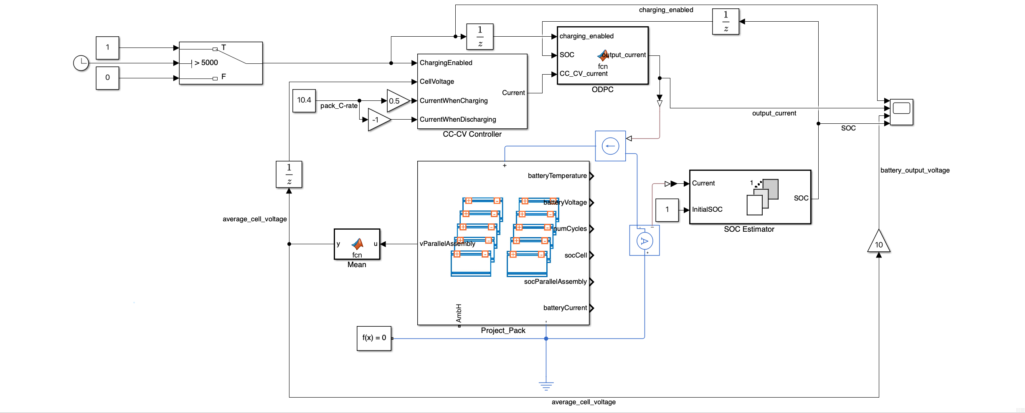
Figure 15
The most significant changes in this version are the new ODPC (Over Drainage Prevention Controller) and the Switch (top left of circuit) blocks.
The ODPC block is a MATLAB function block which takes in 3 inputs and has one output which is the final current that is output at the current source. The function’s MATLAB code looks as follows:
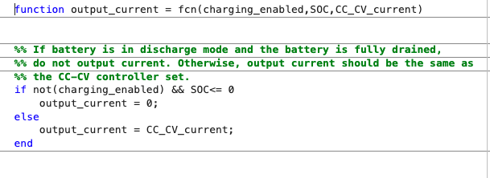
Figure 16
The code is a very simple if else statement which introduces an interrupt to the CC-CV output current and overwrites it with a 0 if the battery is in discharge mode and is fully drained. This MATLAB function block could be easily implemented with a logic circuit using the NOT, AND and the relational operator blocks to do so. I chose to go with the MATLAB function block approach because it makes the schematic simpler and therefore easier to read.
The switch, however, is used to put the battery from discharging to charging mode at around 5000s into the simulation. This enables the simulation to include both the charge and discharge cycles in one go, allowing the different circuit behaviours to be modelled and graphed together.

Output Figure:
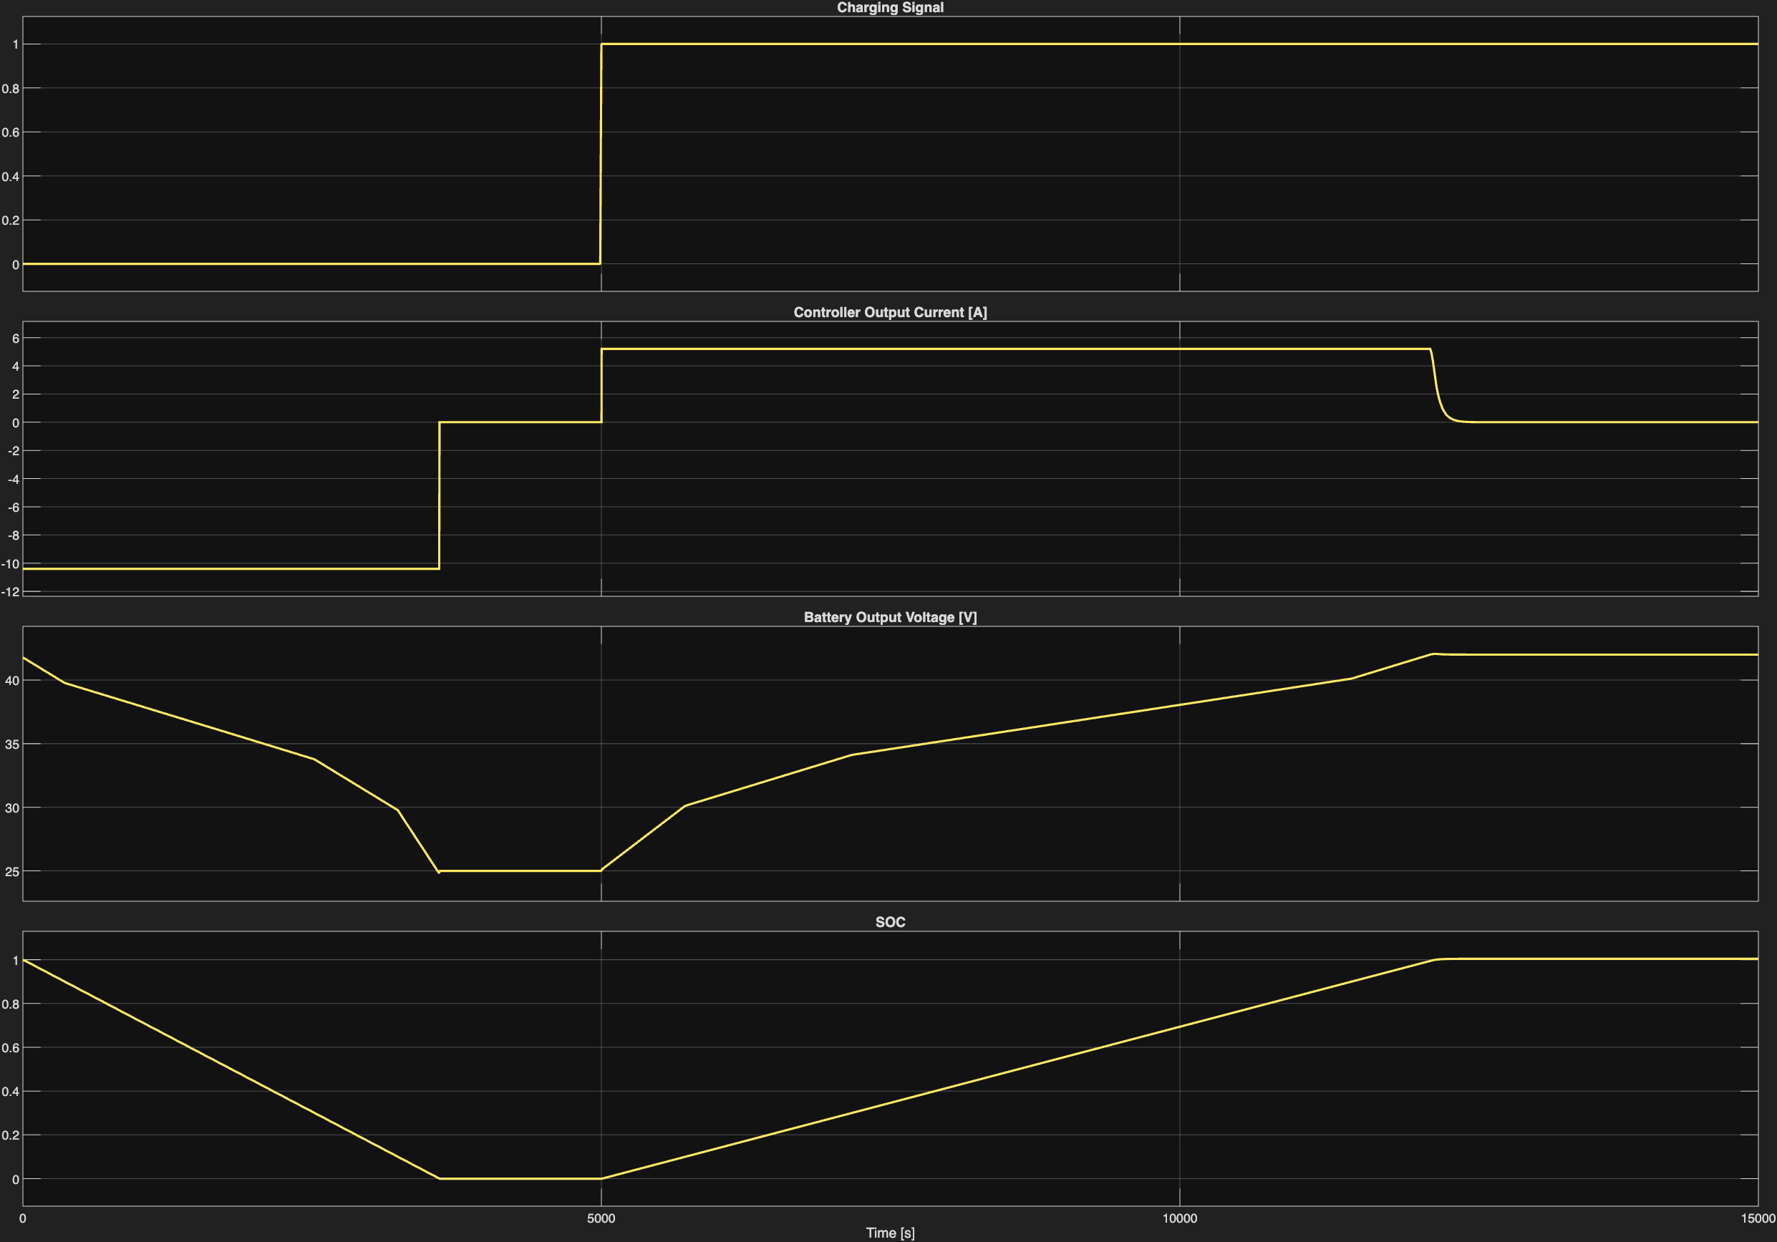
Figure 17
The output figure is exactly what I expected.
In the first region of the graph [Time<3600s], the battery is in discharge mode as the Charging Signal is set to 0. The controller output current is therefore set to 10.4A in the discharging direction. The battery therefore drains appropriately, with the battery output voltage decreasing according to the battery parameters and the SOC decreases linearly.
At the 3600s mark, the battery fully drains. The controller shuts the current off accordingly, as can be seen on the graph above. From then on, the battery output voltage and the SOC remain constant at 25V and 0 respectively, proving that the MATLAB function block is doing its job successfully.
At the 5000s mark, the charging signal goes from 0 to 1, indicating to the system that the battery should now start charging. The controller then sets its output current to the correct value of 5.2A in the charging direction and the battery starts to charge. This can be seen by the battery output voltage and the SOC increasing.
At the 12200s mark, the battery becomes fully charged. To prevent overcharging, the CC-CV controller correctly starts decreasing its output current to then shut it completely which results in the SOC remaining at the value 1.

Version 4 – Different Constant Temperature Conditions
Battery output voltage changes with not only SOC but also temperature. The relationship between these 3 characteristics is given in a battery’s discharge characteristic. When I was researching battery parameters for version 1, I was unable to find a good temperature dependence relationship for my cell so I temporarily neglected the temperature factor by modelling the battery to always be at room temperature. After further research, I have now found a good characteristic graph:
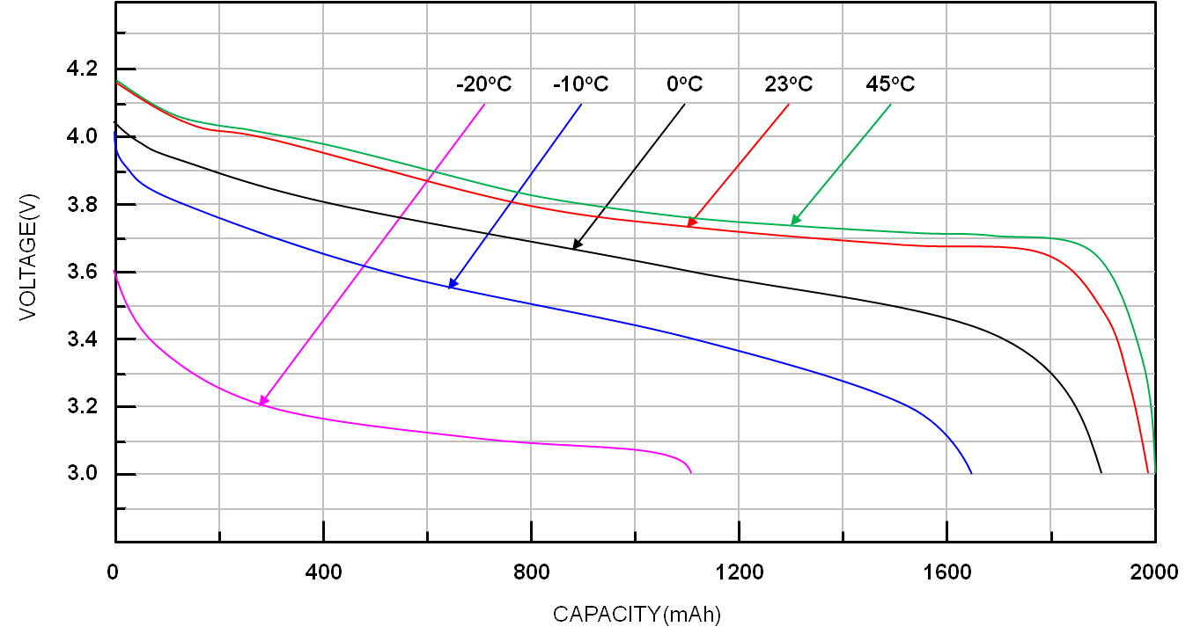
Figure 18
This graph comes from the battery power tips website. The measurements were not taken on the cell I used but on a very similar one. This battery was also a Lithium-Ion cell of output voltage around 3.6V, which is the same as mine. The biggest difference is in the capacity of the cell. This one seems to be around 2000mAh when my one is 2600mAh.
To get the parameters into Simulink I first tabulated the graphed data using a large language model to speed up the workflow. I then computed the matrices required to input this data into Simulink.
I left the battery’s thermal mass and the thermal resistance fields with their default values because these variables would not have changed the result of my simulation. This is because I will keep my batteries at different but constant temperatures, and these parameters govern how heat is produced and dissipated within the battery so play a significant role in scenarios where the battery temperature would be changing.
I decided to use -25, -15, -5, 10, 30, 60 °C as my operating temperatures because they represent all regions between and outside of the 5 different temperature lines on the graph above. -25 and 60 °C are outside of the graphed region meaning that I had to extrapolate the data, which makes these results significantly less accurate than the others. 60°C is also a very high temperature and operating the battery at these temperatures is unrealistic as at these temperatures the battery is likely to become unstable therefore risking thermal runaway. My cell’s data sheet does quote the 60°C temperature as the upper limit for discharging the cell but prolonged use at such temperature would likely be unsafe regardless.
Furthermore, the -15°C, -5°C and 60°C temperatures are outside the manufacturer's charging limits (though within the discharging range), and -25°C is outside the manufacturer's working range for both charging and discharging. This doesn't mean however that the battery will be unsafe to use here, with the exception being the 60 °C, it will just work differently to the way the manufacturer intended. Hopefully the following simulation will show why.

Simulink Schematic:
I made a minor change to the schematic from version 3 before I made it into a subsystem:
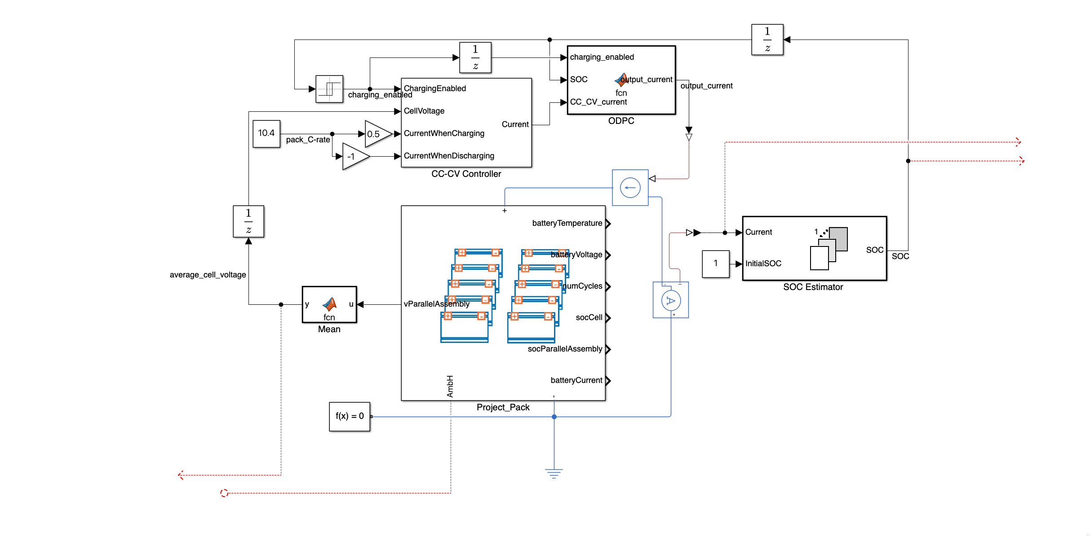
Figure 19
I replaced the clock and the switch with a relay. I set the relay so that the battery is first in discharge mode until the SOC reaches 0 (when the battery becomes fully drained). From there, the relay will put the circuit into charging mode until the SOC reaches 1 (battery is fully charged) where the relay will put the circuit back into discharge mode. And this loop will continue until the end of the simulation.
I then made that circuit a subsystem and used it in the following system:
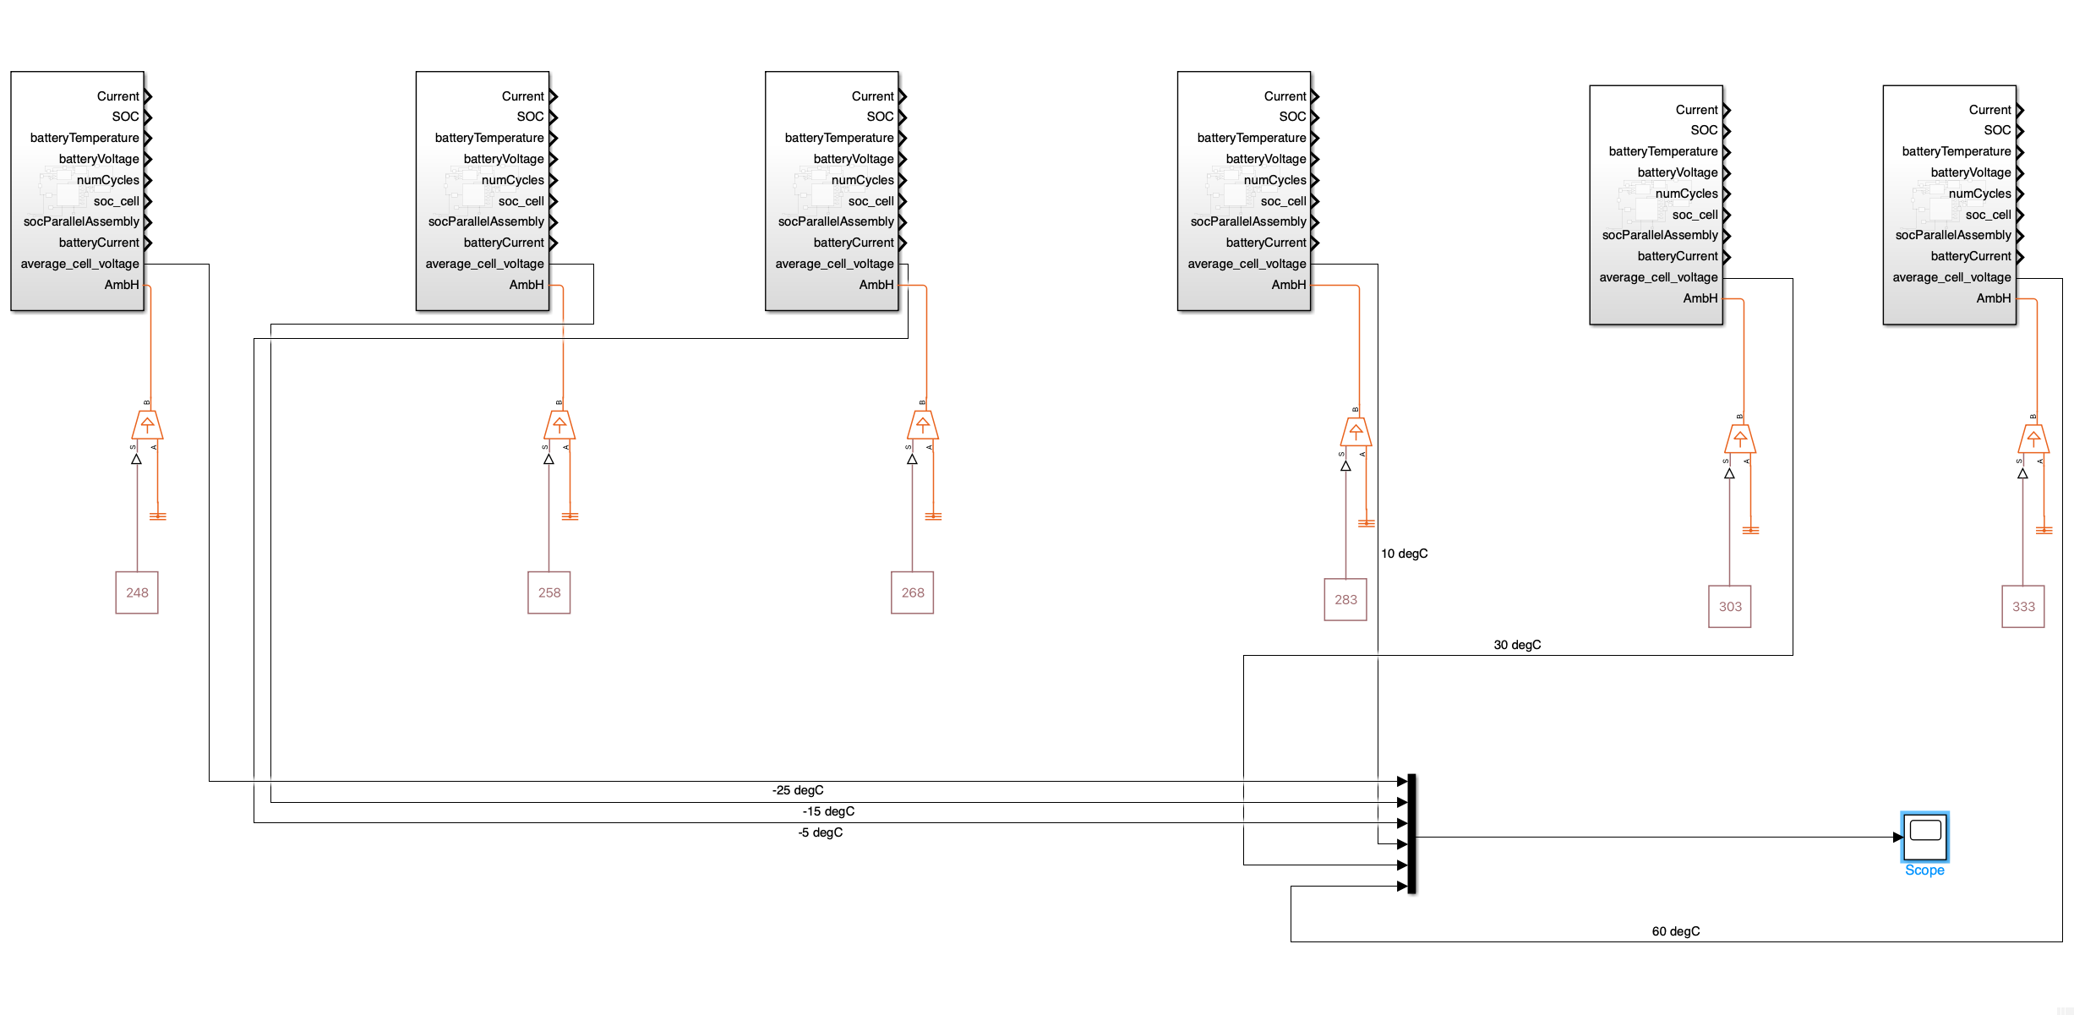
Figure 20 (Temperature values in the schematic are in Kelvin)
I set all the different battery’s initial temperatures to the chosen test values and connected ideal temperature sources to the ambH ports so that the batteries are kept at constant temperatures as can be seen below (graphed results were measured using the internal state batteryTemperature ports):
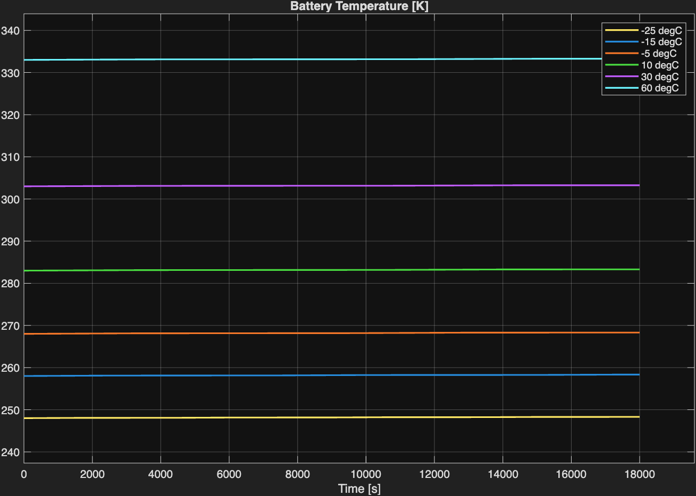
Figure 21

Output Figures:

Constant Capacity:
In that state, the following results were recorded:
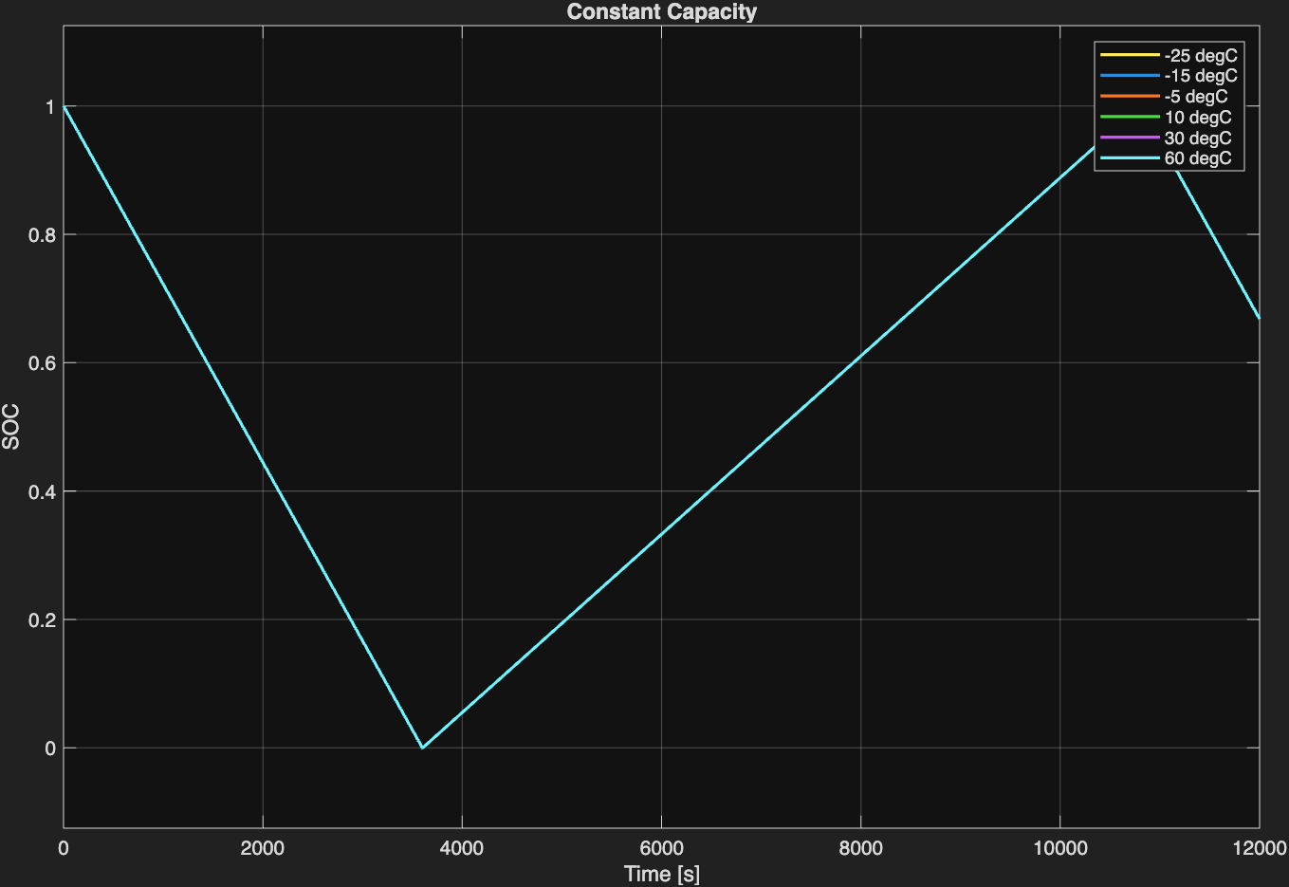
Figure 22
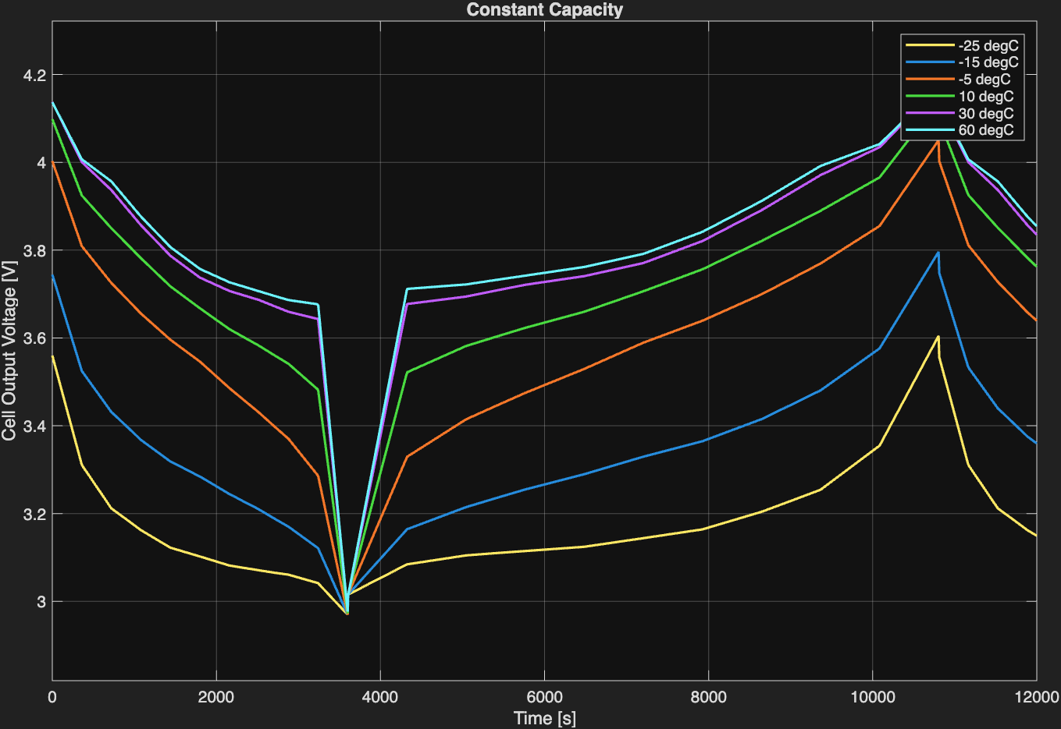
Figure 23
From these 2 graphs, we can see that the cell output voltage does differ depending on what temperature the battery is currently operating at. The trend shown above directly matches the trend shown on Figure 18 - cells operating at higher temperatures output larger voltages but as they become almost drained, the output voltage drops very sharply. The cold batteries show a gentler decrease.
This model however does not consider the fact that the cells’ capacities change with temperature which is a behaviour real cells display as shown on Figure 18.

Temperature Dependent Capacity:
Figure 18 shows research on a cell of a capacity smaller than mine. Furthermore, the graph does not show capacities at my chosen temperatures. To calculate the capacity of my cell in these conditions I used interpolation (and extrapolation for -25 and 60°C results). I first estimated the capacity the cell from Figure 18 would have at the selected temperatures. I then calculated the ratio of the estimated capacity to the cell’s room temperature capacity (at 23°C, the cell’s capacity is 1.98Ah). Finally, to get the capacity of my cell at the specified temperature, I multiplied that ratio by the room temperature capacity of my cell (2600mAh). The results were as follows:
Temperature [°C] | Estimated Capacity [Ah] | Ratio of estimated capacity to room temperature capacity (1.98 Ah) | Ratio * 2.600 Ah | Battery Capacity  *4
-25 | 0.8 | 0.404 | 1.05 | 4.20
-15 | 1.35 | 0.682 | 1.77 | 7.08
-5 | 1.75 | 0.884 | 2.30 | 9.20
10 | 1.92 | 0.970 | 2.52 | 10.08
30 | 1.98 | 1.00 | 2.60 | 10.40
60 | 2.0 | 1.01 | 2.63 | 10.52

I then changed the capacity values in the battery and the SOC estimator in each of the subsystems to the values from the table to produce the following result:
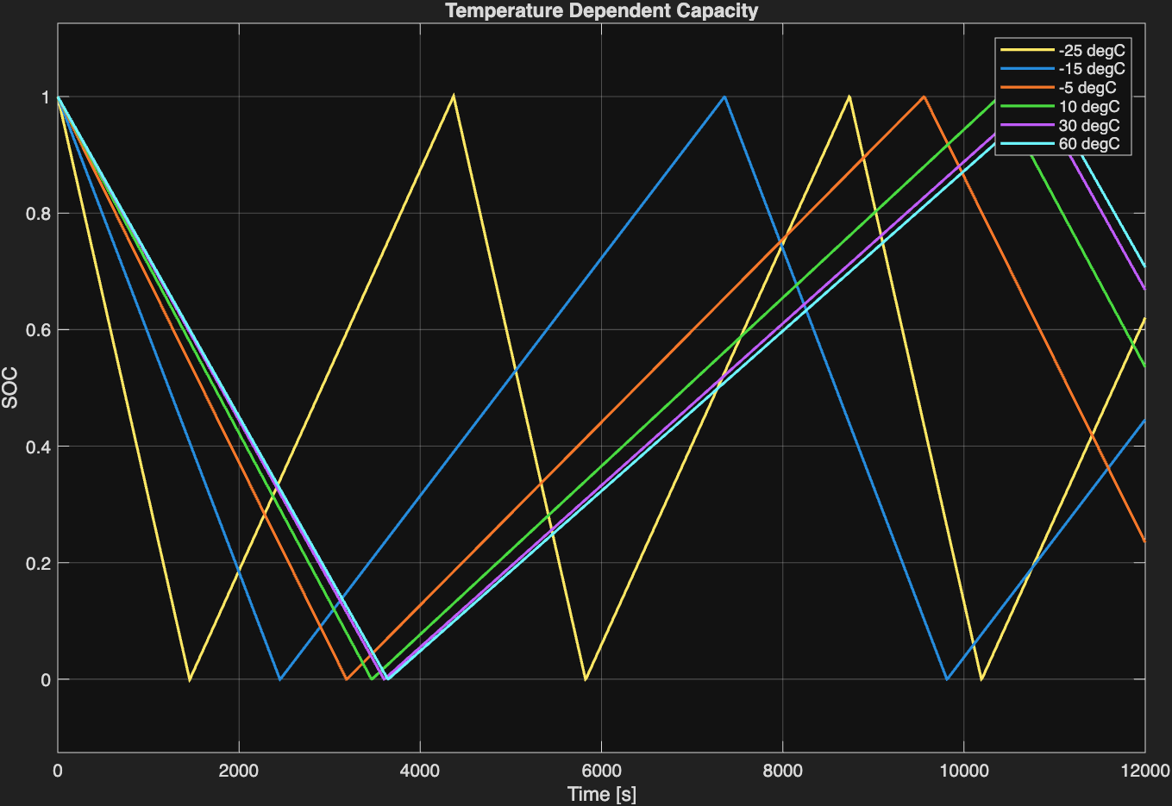
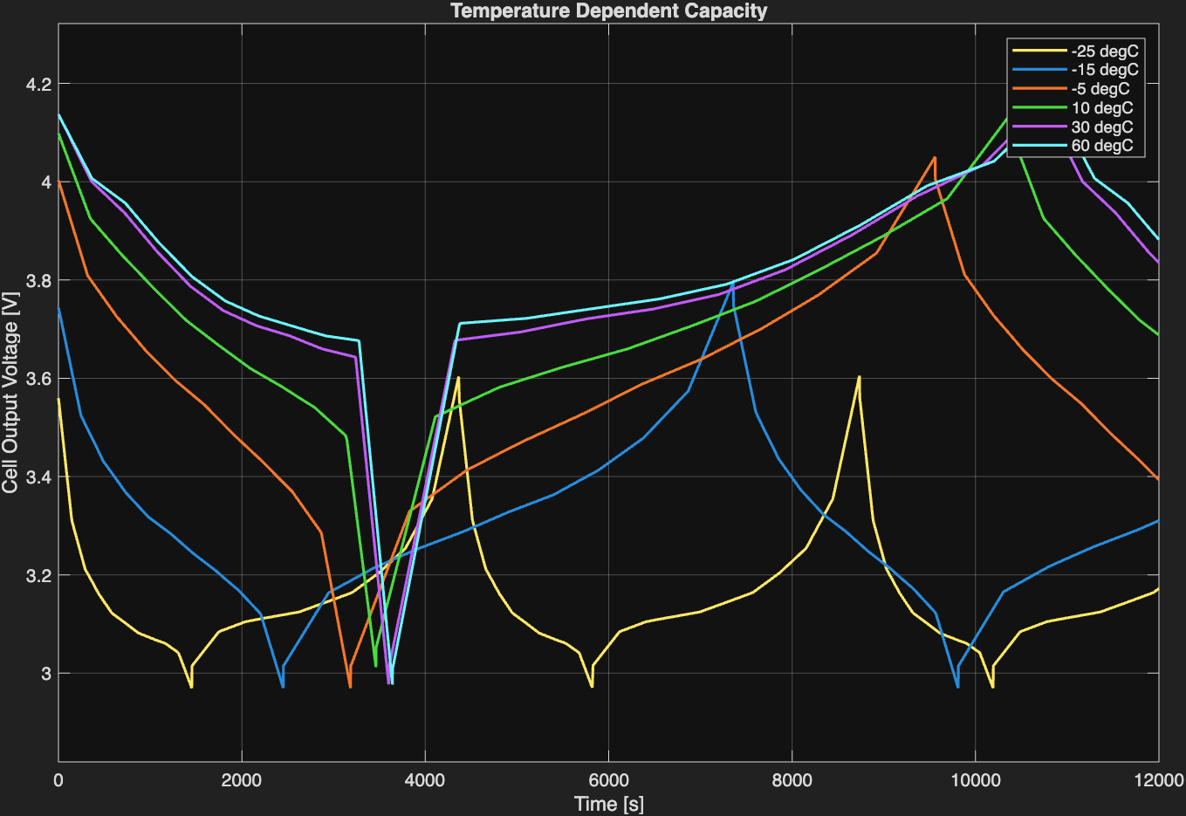

The change in capacity has a significant effect on the graphs. Although the voltage output remains largely unchanged, the cells now charge and discharge at considerably different times. This difference can be substantial. For example, when comparing the two most extreme temperatures, the cell at -25°C not only fully discharges but also almost fully recharges in the same amount of time that the cell at 60°C takes to complete the discharging stage and begin the charging phase.
It is also interesting to compare the behaviour of the battery at -25°C, 10°C, and 60°C. Although the battery at 10°C shows a small difference in output voltage compared with the battery at 60°C, this difference is relatively insignificant, and their capacities are also similar. In contrast, the battery at -25°C shows a substantial decrease in both cell output voltage and capacity. This is particularly notable because the temperature difference between -25°C and 10°C is smaller than the difference between 10°C and 60°C, and yet the effect on battery performance is much greater at the lower temperature.
The graphs above also help explain why the manufacturer specifies a discharge operating temperature of 20-60°C. Outside the specified range, the cell outputs a significantly lower voltage, meaning the battery will perform less effectively when powering an electric motor.
Therefore, accounting for battery temperature is important in these types of simulations, as cell behaviour and performance can vary significantly with temperature, particularly under low-temperature conditions.

Conclusion
Overall, I was successful in designing, creating and implementing the researched battery. I also implemented a current controller to ensure that the battery charges and discharges according to its specified safe current limits and an additional algorithm to estimate the battery’s SOC. Furthermore, I also modelled how cell output voltage and capacity vary with temperature to produce useful and easy to read graphs. In the future, I could expand on the project further by replacing the controlled current source with a motor model to assess the battery and motor’s performance under different temperatures and loads. Another option would be to model the battery’s heat generation and compare its performance under different cooling conditions such as conductive heat losses when stationary and convective heat losses when moving.

